CREATE JAVA WEB APPLICATION

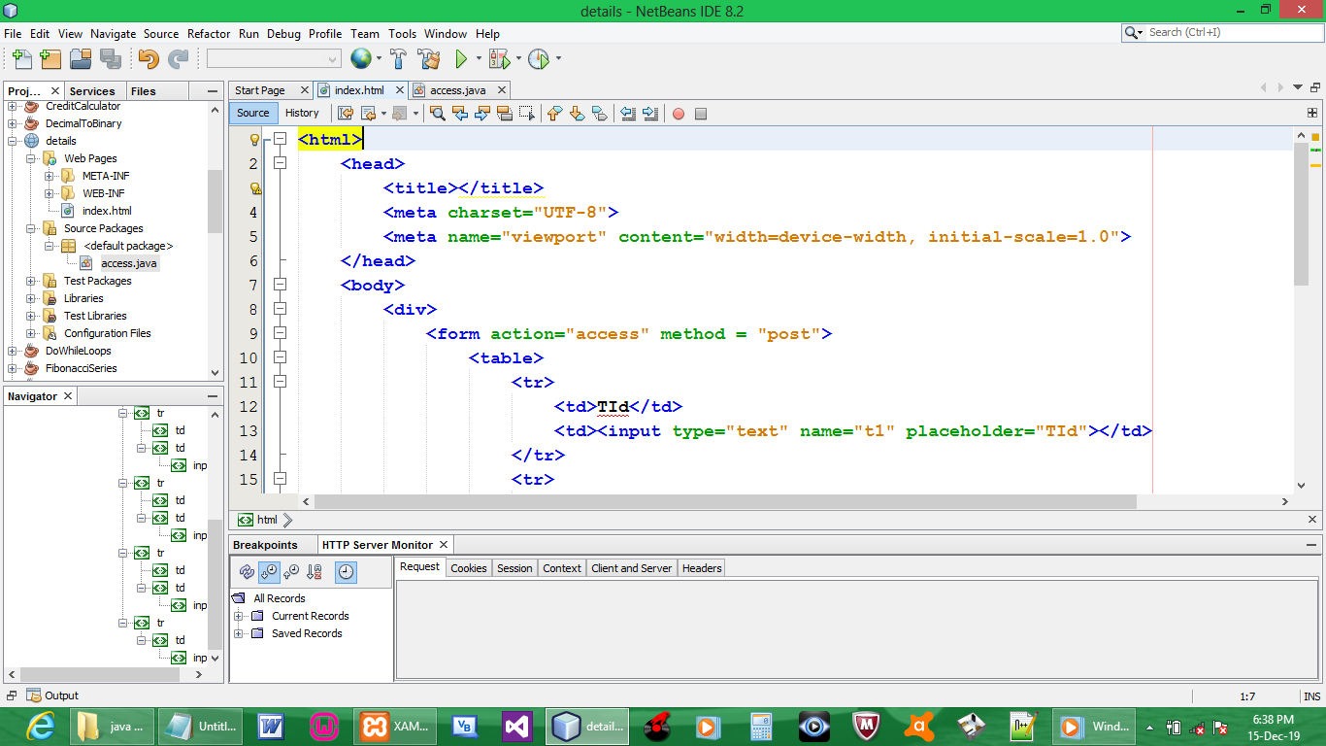

CODE:

<html>
<head>
<title></title>
<meta charset="UTF-8">
<meta name="viewport" content="width=device-width, initial-scale=1.0">
</head>
<body>
<div>
<form action="access" method = "post">
<table>
<tr>
<td>TId</td>
<td><input type="text" name="t1" placeholder="TId"></td>
</tr>
<tr>
<td>Name</td>
<td><input type="text" name="t2" placeholder="Name"></td>
</tr>
<tr>
<td>Address</td>
<td><input type="text" name="t3" placeholder="Address"></td>
</tr>

<tr>
<td colspan="2" style="text-align: center"><input type="submit" value="Submit"></td>
</tr>
</table>
</form>
</div>
</body>
</html>

CREATE SERVLET

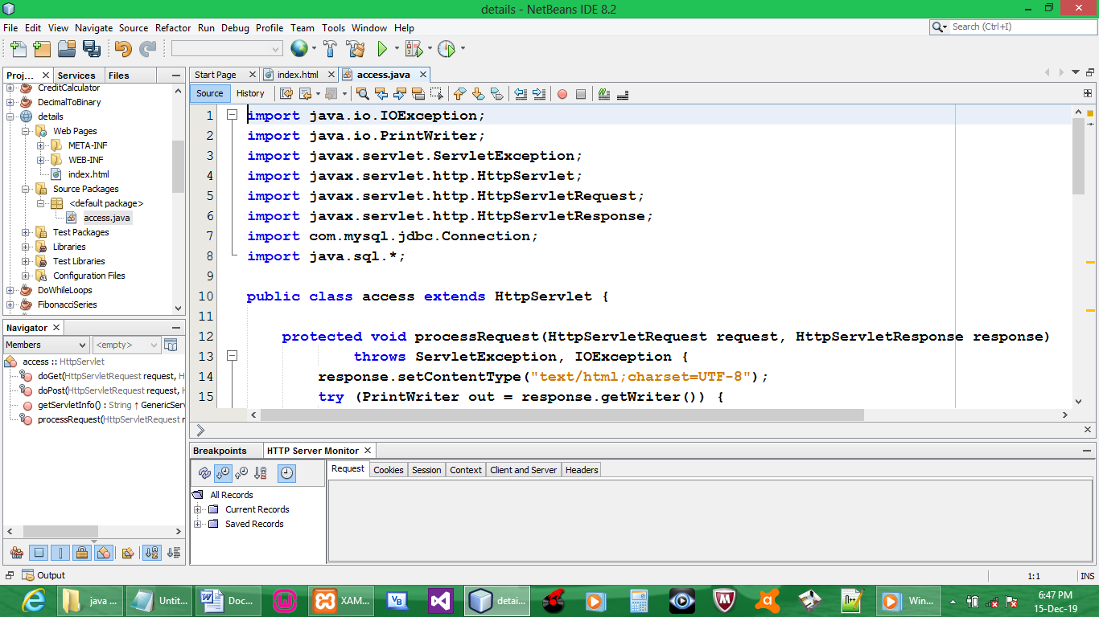

CREATE DATABASE
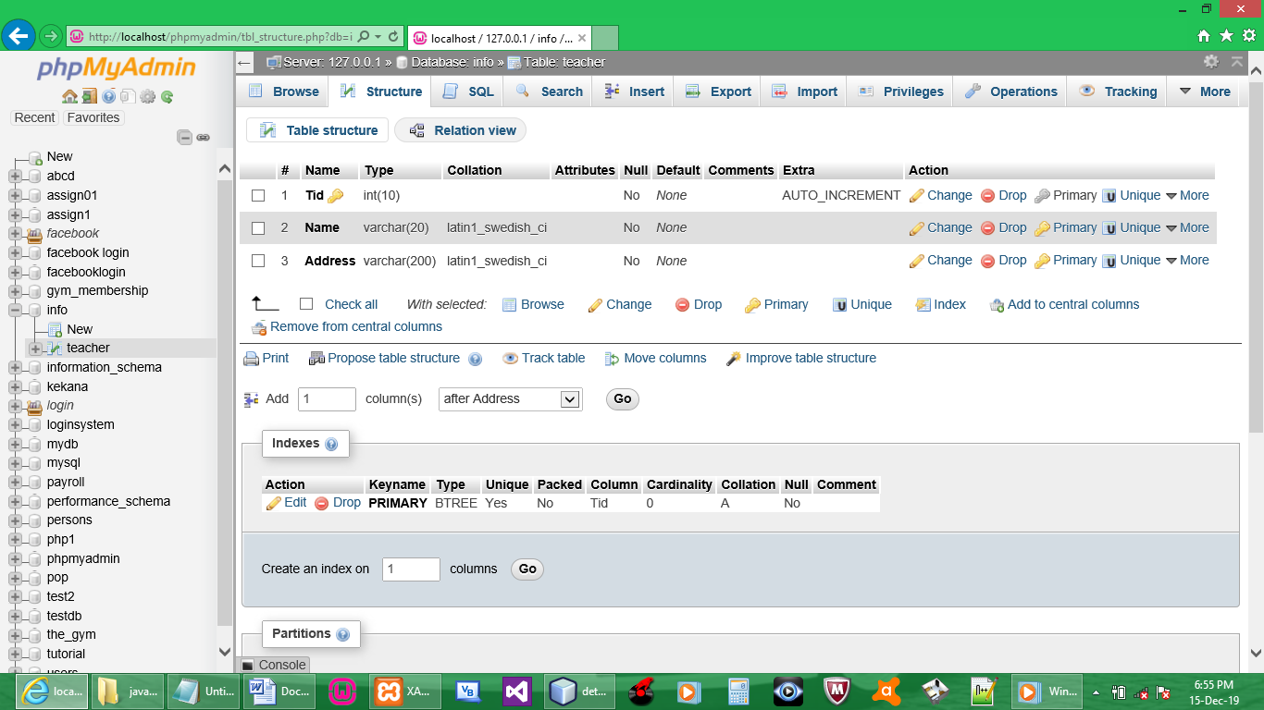

ADD LIBRARY

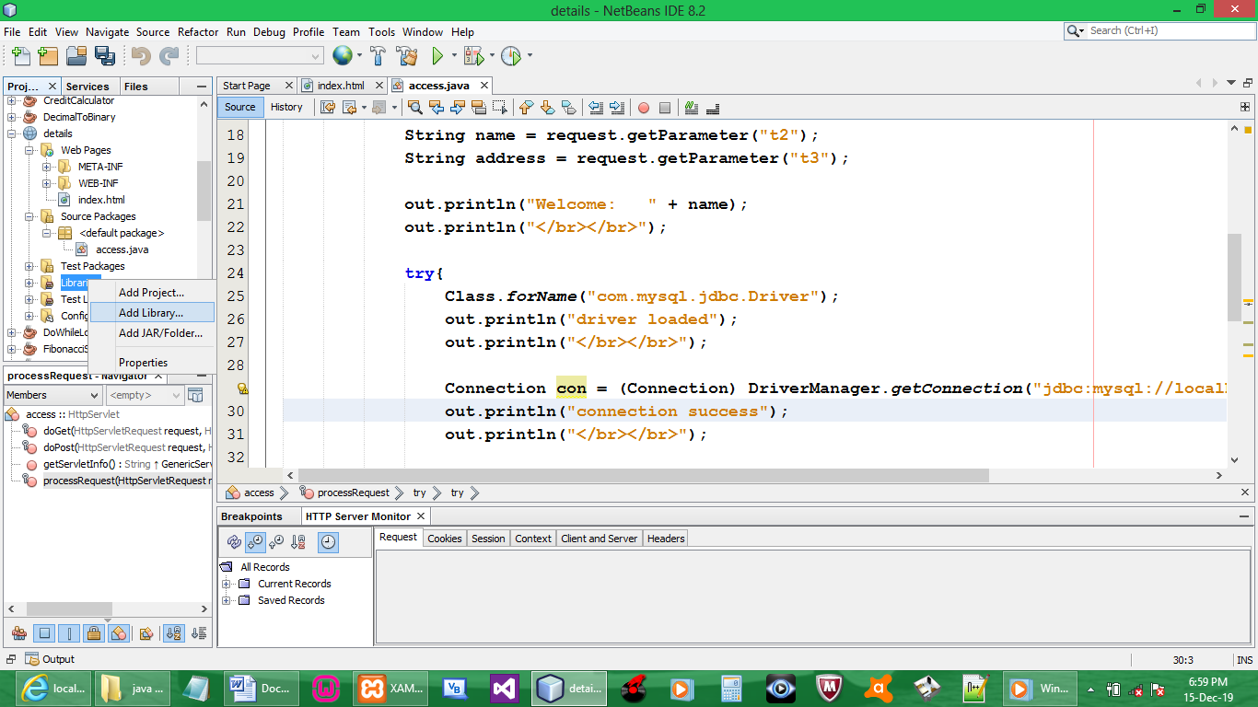

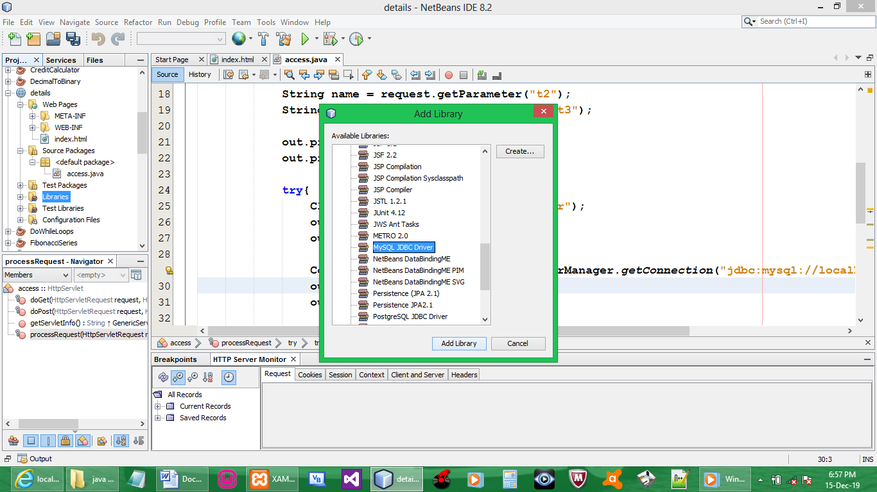

CREATE CONNECTION

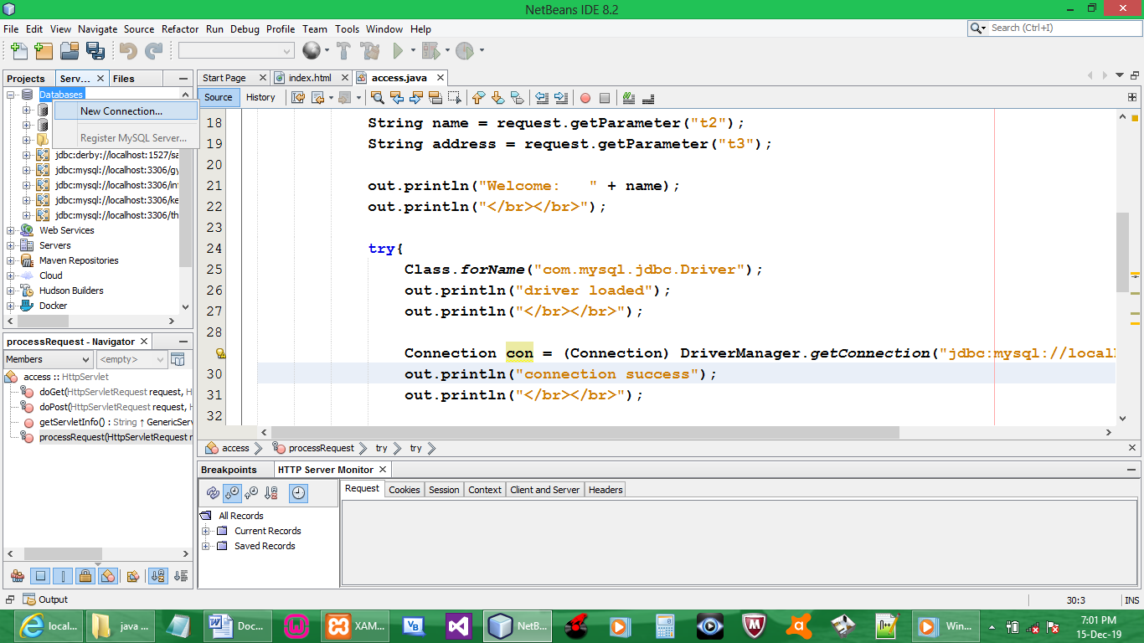

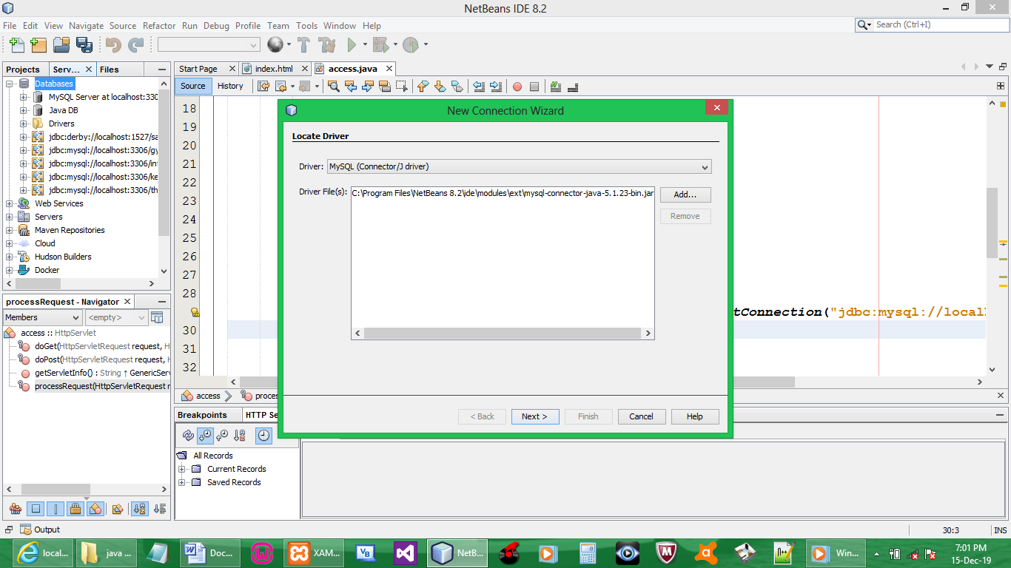

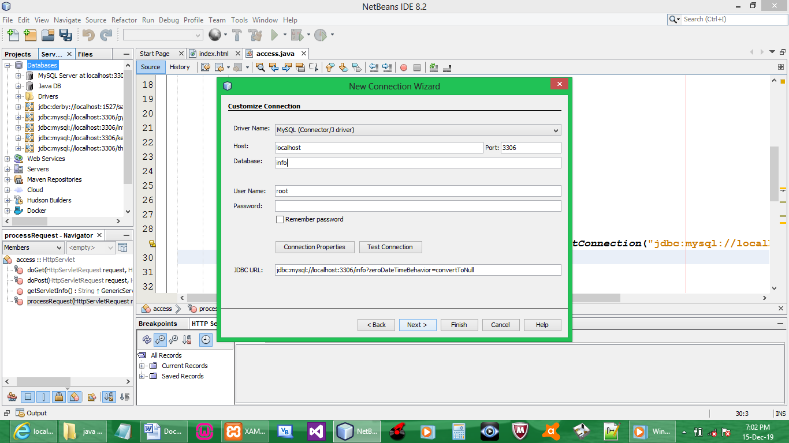

Connection created
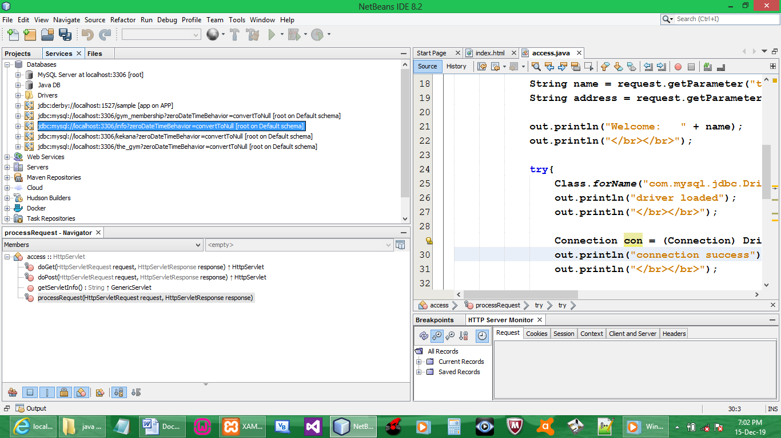

CODE:

import java.io.IOException;
import java.io.PrintWriter;
import javax.servlet.ServletException;
import javax.servlet.http.HttpServlet;
import javax.servlet.http.HttpServletRequest;
import javax.servlet.http.HttpServletResponse;
import com.mysql.jdbc.Connection;
import java.sql.*;

public class access extends HttpServlet {

protected void processRequest(HttpServletRequest request, HttpServletResponse response)
throws ServletException, IOException {
response.setContentType("text/html;charset=UTF-8");
try (PrintWriter out = response.getWriter()) {

String id = request.getParameter("t1");
String name = request.getParameter("t2");
String address = request.getParameter("t3");

out.println("Welcome: " + name);
out.println("</br></br>");

try{
Class.forName("com.mysql.jdbc.Driver");
out.println("driver loaded");
out.println("</br></br>");

Connection con = (Connection) DriverManager.getConnection("jdbc:mysql://localhost:3306/info", "root", "");
out.println("connection success");
out.println("</br></br>");

Statement stmt = con.createStatement();
stmt.executeUpdate("insert into teacher values ('"+id+"', '"+name+"', '"+address+"');");
out.println("Succesfully Added");
con.close();
}
catch (Exception e){
}
}
}

OUTPUT:

